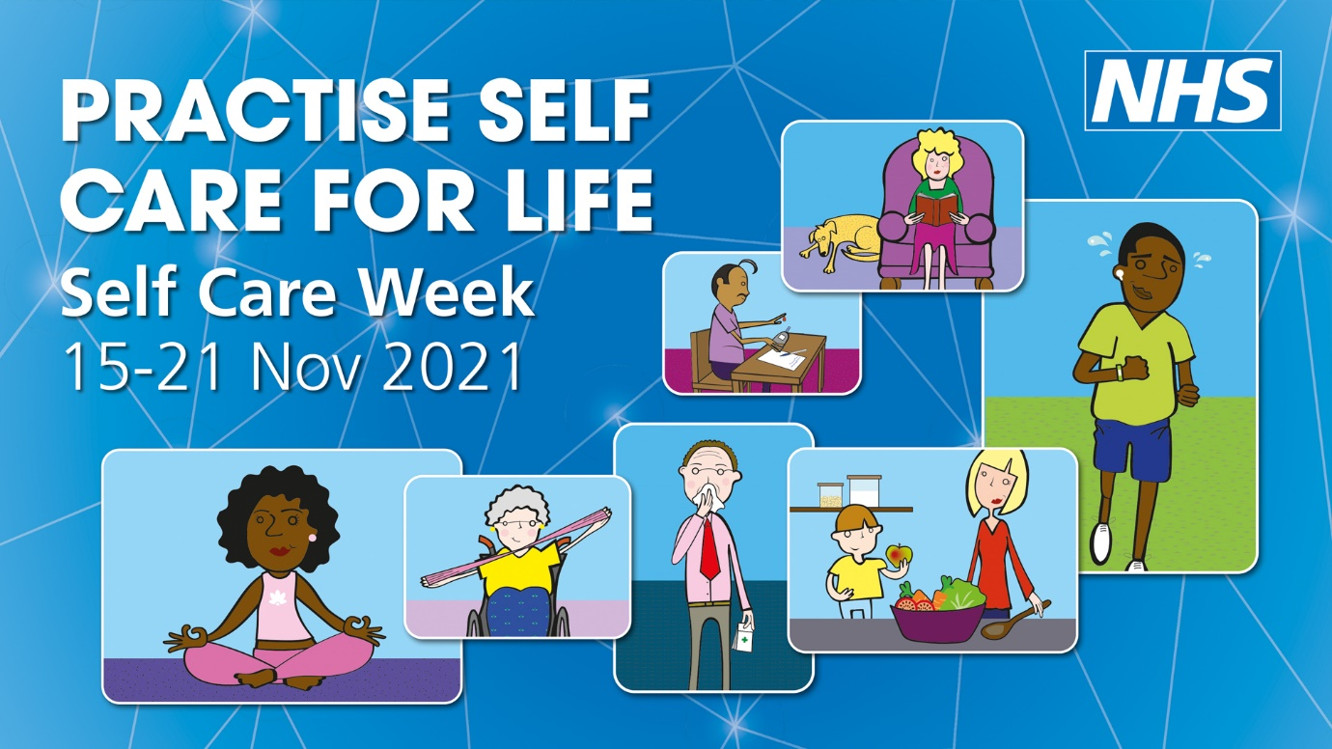

Self Care Week Reminds us to Practise Self Care for Life
Self Care Week is the annual national event that raises awareness of what we can all do to improve our physical health and mental wellbeing. This year, the theme is Practise Self Care for Life.

The organiser of Self Care Week is the Self Care Forum, a charity which aims to empower and encourage everyone to make self care their everyday habit. And the Self Care Forum knows just how important this message is, particularly when times are as tough as they are right now.

Incorporating the practise of self care into our everyday lives can help us to live as healthily as possible. And better health for us can help us cope better with the challenges that come our way.

Self Care Week is a perfect time to think about how we live our lives and maybe make some small changes that will help us take better care of ourselves and our families. Those changes could mean looking at what we eat or drink, or how much exercise we do or how much sleep we are getting. They could be about our work life balance, because staying connected to our friends and family is also vital to our wellbeing, and theirs.

Knowing what to do and where to go for help is an important part of practising self care for life. Remember, it isn’t just the GP practice that can help, pharmacies are also health experts. They are on every High Street and can help with all sorts of ailments. Pharmacists can also signpost you to the right place for additional health advice or treatment.

Remember, NHS 111 can also be a good resource for health advice for things that are not life-threatening. And the NHS website has lots of information on what steps to take to look after you and your family. https://www.nhs.uk/ The Self Care Forum also has some useful fact sheets you might like to download. https://www.selfcareforum.org/fact-sheets/

The important thing to remember is, practising self care is something we all need to do every day. For ourselves. For our families. And for the NHS.

